**Phase – II**

**Practice Project – IV**

**Product Details**

**Sai Krishna Rajagopal**

**22-03-2022**

1. Screenshots:

Output:

Index Jsp:

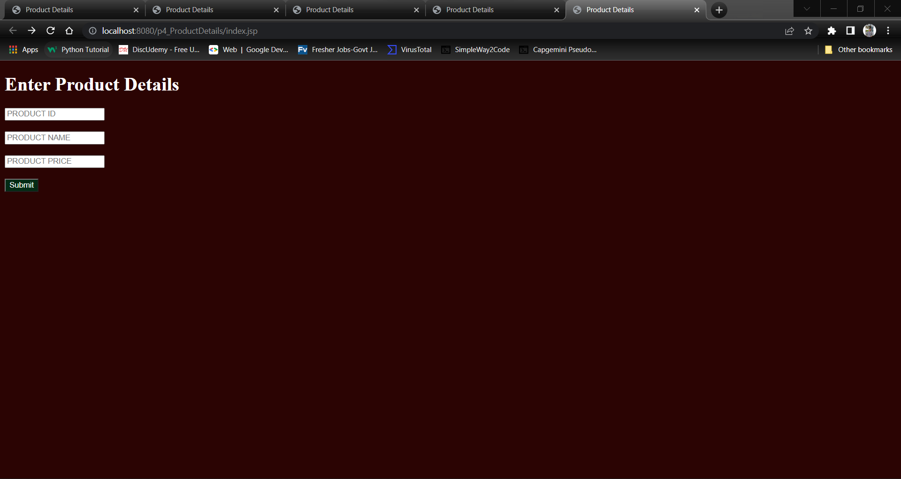

Display Jsp

Output1:

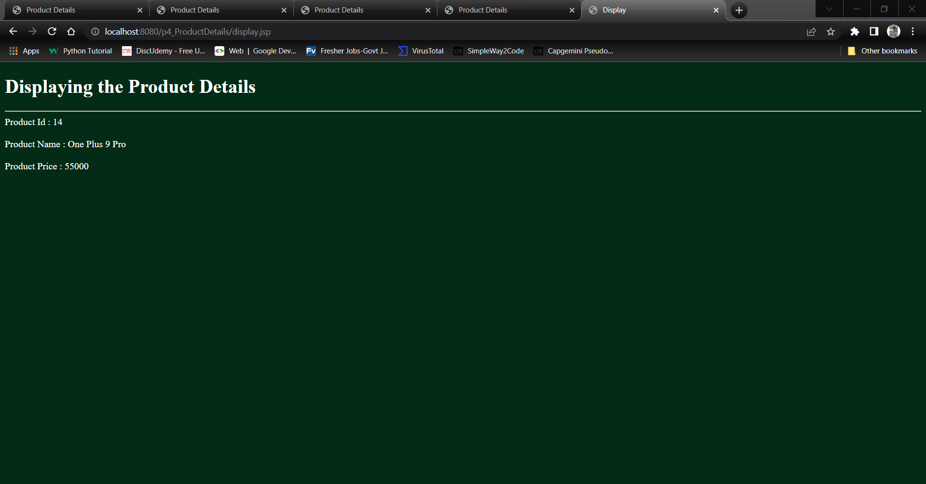

Git:

